**GIT Commands**

1. Initialization of GIT

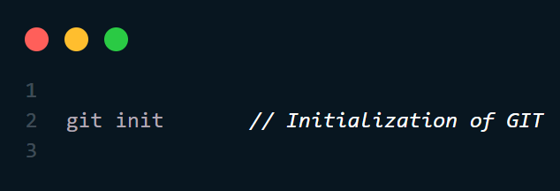

1. Add changes to GIT

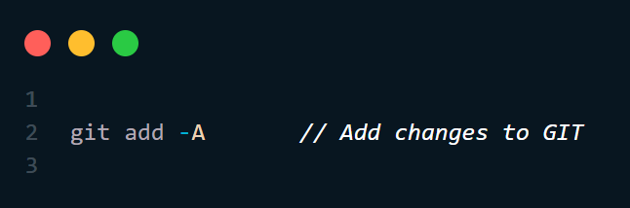

1. Commit the changes

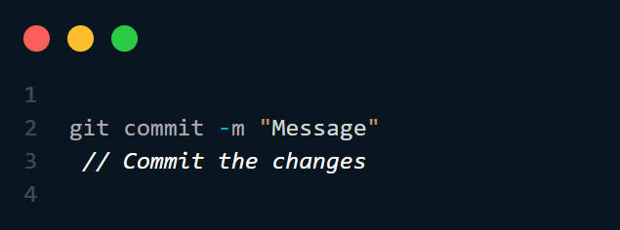

1. Renaming the branch name

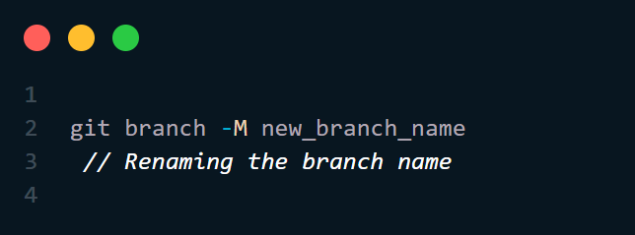

1. Cloning GIT Repository

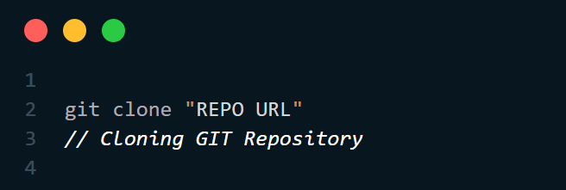

1. Pushing the changes to GIT

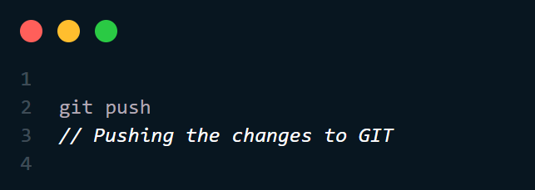

1. Checking the status of GIT Repository

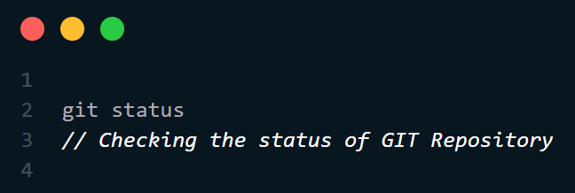

1. Show the branches

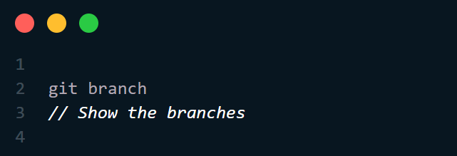

1. Create the branch

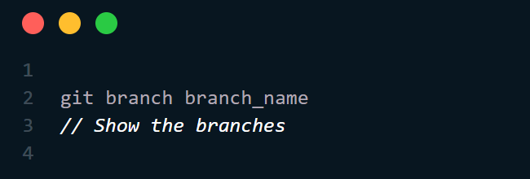

1. Shift between branches

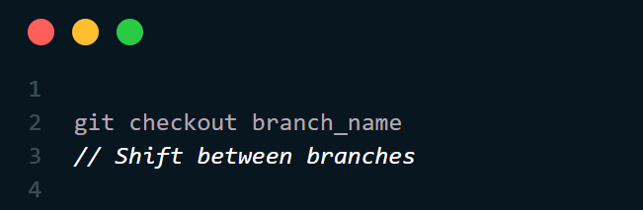

1. Push the latest branch to GIT

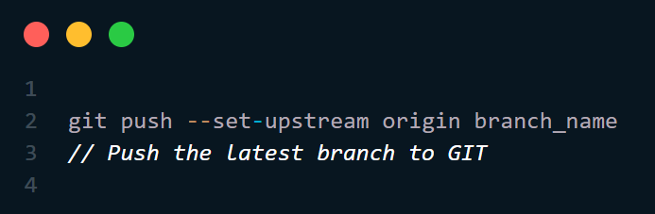

1. Pull the latest changes from GIT

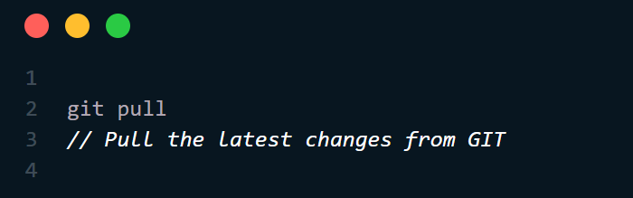

1. Pull the latest changes from particular branch

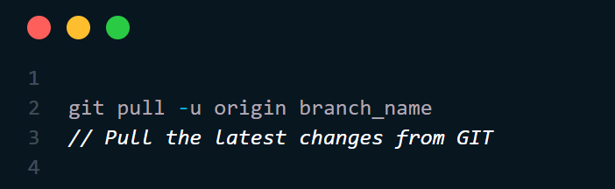

1. Revoke the recently committed changes

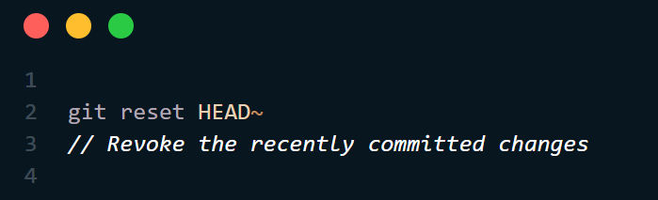

1. Revoke the added the changes

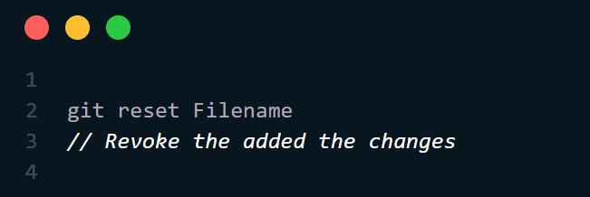

GIT Login Commands

git config user.name my-name

git config user.email "my-email"